Home Equity Reverse Mortgage Information Technology
(HERMIT)

HERMIT System Changes – Release 6.8

Release Date: 08/06/22
Document Date: 08/06/22

August 2022

INTRODUCTION
The Home Equity Reverse Mortgage Information Technology (HERMIT) software release version 6.8 consists of the following system changes:
Table of Contents
Servicer Only Related Changes / Endorsed Loans 3
1. Loan Setup Monthly ARM First Change Date updates (582923) 3
Servicer / NSC related changes 5
1. DMF (Death Master File) Update to only match SSN on Borrower, Co-Borrowers, & NBS (580394) 5
2. Property Value Page Update (576312) 5
3. Add New Report displaying daily SAMS Interface Data file (539362) 5
4. Add a new LESA Checkbox and LESA Report (546883) 6
5. Claim Type 22 MOE Assignment Curtailment Changes (575686) 8
6. COVID Claims Extension timeline new Reason for Extension option “CT22 – MOE Assignment” (579509) 8
7. Claim Type 22 MOE Assignment COVID Extension to Curtailment Deadline (579509) 8
8. Claim Type 21: Foreclosure, Appraisal Based Claim – Update how Block 10 is populated using Marketable Title Extension Expiration Date (581595) 9
9. Rename step on Loss Mitigation – Short Sale timeline to “Deed Recorded Date / Post-Death Title Transfer” (571076) 9
10. Claim Type 23: Heir Sale with No Deed Recorded Date (571076) 10
11. Claim Types 21 and 23: Itemize Partial Repayments in section 305 of the Claim Form if the Effective Date is after Block 17 UPB Cutoff Date (581401) 10
12. Claim Types 21, 23, and 24: AOP Page 2 and Claim AOP Amounts Report (542965) 11
13. Prevent an Investor Change After the 27011 is Submitted for CT21, CT23, or CT24 (575661) 14
HUD Only Related Changes / Assigned Loans 15
1. Repurchase (582646) 15
2. Add a new step and Write-Off worksheet to Write-Off Timeline (539298) 15
3. Add Loan Bal on Trans Dt Column to the Loan Transactions Page (539459) 18

If you have any questions regarding the functionality of the software release, please contact the HERMIT Help Desk at 561-899-2610 or at servicingsupport@hermitsp.com. If you have any policy related questions, please send an email to HUD at answers@hud.gov.

Servicer Only Related Changes / Endorsed Loans

Loan Setup Monthly ARM First Change Date updates (582923)
Two changes were made in Loan Setup affecting both Loan Setup via User Interface (UI) and B2G for loans with Rate Type “Monthly.” The first change was a revision to the validation used for the ARM First Change Date, which was split into 2 rules: rules for loans with a Closing Date on January 31 of any year, and rules for loans with any other Closing Date besides January 31. See “A” for more information.
A. Monthly ARM First Change Date Validations:
For loans with a Closing Date on January 31, the Loan Setup validation for the ARM First Change Date validation no longer requires a 30 day minimum from the Closing Date and shortened the maximum ARM Change Date from 6 months to 3 months. The updated validation is:
i. ARM First Change Date must be the 1st of the month and
ii. ARM First Change Date must be > Closing Date and
iii. ARM First Change Date must be <= 3 months from Closing Date
For loans with a Closing Date other than January 31, the Loan Setup validation for the ARM First Change Date shortened the maximum ARM Change Date from 6 months to 3 months. The updated validation is:
i. ARM First Change Date must be the 1st of the month and
ii. ARM First Change Date must be >= 30 days from Closing Date and
iii. ARM First Change Date must be <= 3 months from Closing Date

The second change is new logic for loans with a Closing Date on January 31 of any year that will be used to determine if the ARM First Change Date is eligible for the Interest Rate to be updated on the date that was entered by the user. If the Interest Rate is not eligible to be updated, the Interest Rate at Closing will remain in effect until the rate is eligible to be updated.
Although the ARM First Change Date on loans with a Closing Date on January 31 will now be permitted by the system, if the ARM First Change date is less than 30 days from Closing Date, the Interest Rate will not be updated as the Interest Rate is not eligible to update based on existing HUD rules. See “B” for more information.

B. Is Interest Rate eligible to change on Monthly ARM First Change Date:
For loans with a Closing Date on January 31, when the ARM First Change Date is less than 30 days from the Closing Date, the Interest Rate is not eligible to change on the ARM First Change Date. The system will not update the Interest Rate on ARM First Change Date and the Initial Interest Rate will remain in effect until the next rate change.
When the Interest Rate is not eligible to change on the ARM First Change Date, a popup will be displayed during Loan Setup or Edit Loan Details, and an Auto-Note and Alert will be saved to respective areas.
- New informational popup will be displayed with OK and Cancel buttons, stating “Current Interest Rate will not change on ARM First Change Date because Current Index is not the most recent Index figure available thirty (30) days before the Change Date.”
- New B2G Loan Setup warning “Current Interest Rate will not change on ARM First Change Date because Current Index is not the most recent Index figure available thirty (30) days before the Change Date.”
- Auto-Note will be saved to the loan on the Notes page stating “Current Interest Rate will not change on ARM First Change Date because Current Index is not the most recent Index figure available thirty (30) days before the Change Date.”
- Alert will be saved to the Alerts page stating “Curr Int Rate will not change on ARM 1st Change Date since Curr Index is < 30 days from Change Date.”

For loans with a Closing Date on January 31, when the ARM First Change Date is 30 days or more from the Closing Date, the Interest Rate is eligible to change on the ARM First Change Date. The system will update the Interest Rate on the ARM First Change Date.
For loans with a Closing Date other than January 31, the Interest Rate is eligible to change on the ARM First Change Date. The system will update the Interest Rate on the ARM First Change Date.

Servicer / NSC related changes

DMF (Death Master File) Update to only match SSN on Borrower, Co-Borrowers, & NBS (580394)
HERMIT has been updated to receive the DMF records on an SSN match for Borrower, Co-Borrower, & NBS only, no other contact types will be updated by the DMF for both Endorsed and Assigned Loans. The DMF report under Servicer Reports > Daily Reports will only display Borrowers, Co-Borrowers, and NBS records, no other contact types will be displayed on the report going forward.

Property Value Page Update (576312)
  - To address incorrect appraisal information entered by a user, Users will now have the ability to delete a Property Value record that they created. The Original Value cannot be deleted. Upon entering appraisal information into the Property Value page, the following confirmation message will be displayed:
Message: Please confirm that the value provided on the uploaded appraisal document
matches the value manually entered in the "As Is Value(Estimated)" field by the service.
  - User will not have the ability to EDIT records after they are created, they can only be deleted. Should the User incorrectly enter appraisal information into the Property Value page; users will have the ability to delete the incorrect entry and then re-enter to correct appraisal information.
  - As a reminder, servicers are required to update the Property Value Page with ALL appraisal information and supply such documentation as part of the claim package.

Add New Report displaying daily SAMS Interface Data file (539362)
A new report called SAMS Daily Transaction File has been added to the HERMIT reports area under Assigned Notes Reports/Daily Report. Users will be able to generate a report displaying the data generated in the daily Single Family Acquired Asset Management System (SAMS) interface file. The report will have the ability to list all Foreclosure and DIL activity sent to SAMS.
Data from the SAMS files that were generated and sent previously will be converted from 10/1/2020 onwards. Data prior to 10/1/2020, will be provided as requested.
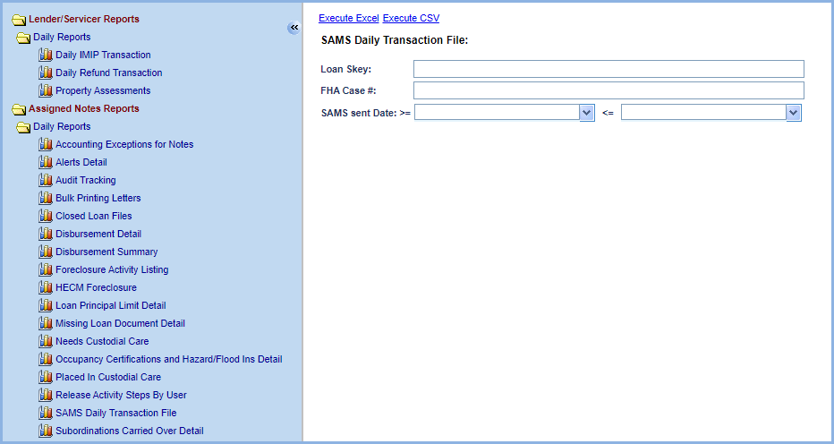

Report output will be in Excel and CSV and have the following fields:
- FHA Case #
- ADP Code
- Fund
- Cohort
- Endorsement Date
- Property Address 1
- Property Address 2
- City
- State
- Zip
- Principal – BC
- Expense – EC
- Net Total – CC
- Accounting Period
- Closing Code DIL or FC
- SOA
- Custodial Care Request Date
- Custodial Care Placed Date
- Acquisition Type
- Fee Status
- Area for Custodial Property
- Recorded Date for Deed
- SAMS Sent Date
- All Monetary columns will be summed up with a total under the column

Add a new LESA Checkbox and LESA Report (546883)
A new LESA checkbox has been added to the Loan Search page. When selected, Loan Search Results will include loans with any LESA Type, including Fully Funded, Partially Funded or Voluntary.
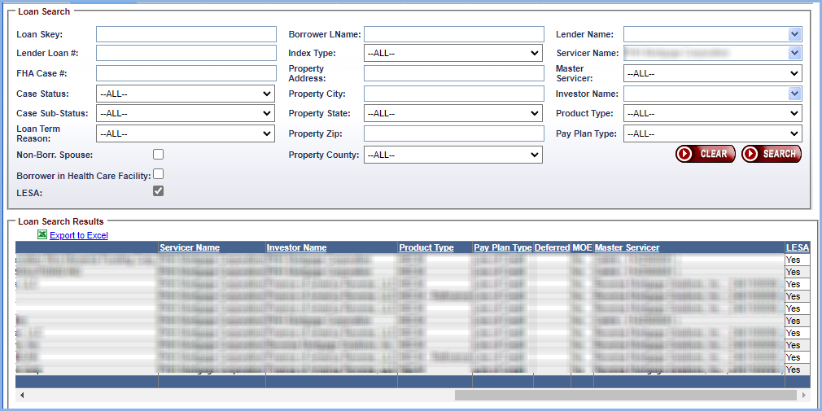

Report:
A new report called LESA (Life Expectancy Set Aside) has been added to the HERMIT reports area under Servicer Reports/Daily Report. Authorized Users will be able to generate a LESA report to include loans with a Fully Funded, Partially Funded, Voluntary or ALL.
The Servicer Name field will be read only when a Servicer User logs in. Servicers will be able to search and run reports on loans within their portfolio based on Lender Name, Investor, or both.
When a HUD User logs in, they will be able to search and run reports for individual Lenders, Investors and Servicers or for ALL
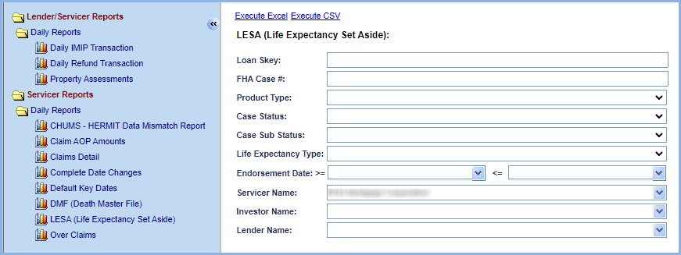
Report output will be in Excel and CSV and have the following fields:
- Loan Skey
- FHA Case #
- Endorsement Date
- Case Status
- Case Sub-Status
- Servicer FHA Mortgagee #
- Servicer Name
- Investor Name
- Lender Name
- Product Type
- Life Expectancy Type (Fully Funded, Partially Funded or Voluntary)
- Life Expectancy Payment Type (Active Payments or Payment Suspended)
- LESA Setup Effective Date
- LESA Setup Transaction Date
- LESA Setup Trans Code (automatic populates for 6610)
- LESA Setup Amount
- Current LESA Balance

Claim Type 22 MOE Assignment Curtailment Changes (575686)
CT22 MOE Assignment curtailment logic was updated to determine curtailment based on “Submit Assignment Request to HUD” step completion date. Curtailment rule is Claim Type 22 - Assignment Timeline “Submit Assignment Request to HUD” step completion date must be within 180 days of latest borrower / co-borrower death date to avoid curtailment. If step completion date is after latest borrower / co-borrower death date + 180 days, the claim will be curtailed.

COVID Claims Extension timeline new Reason for Extension option “CT22 – MOE Assignment” (579509)
A new Reason for Extension dropdown option titled CT22 – MOE Assignment was added to “Extension – COVID-19 Request to Delay Claims Submission” timeline. This reason can only be selected during timeline Setup or Servicing Mgmt Edit if the loan has an existing Claim Type 22 – Assignment timeline WITH the “MOE Assignment” box selected. If the necessary conditions do not exist to create the timeline with this reason, error message will display: “Reason for extension CT22 – MOE Assignment cannot be selected because there is not a corresponding CT22 Claim Timeline with MOE Assignment. Please create necessary Claim Timeline then try again.”

The “Extension – COVID-19 Request to Delay Claims Submission” timeline is still subject to the same existing rules for maximum number of COVID extensions permitted based on initial COVID Extension Request Date.

Claim Type 22 MOE Assignment COVID Extension to Curtailment Deadline (579509)
Claim Type 22 MOE Assignment Auto-curtailment logic was revised to set CT22 MOE Curtailment Deadline to the Extension Expiration Date of “Extension – COVID-19 Request to Delay Claims Submission” with Reason for Extension CT22 – MOE Assignment. If more than one timeline with necessary criteria exist, the latest Extension Expiration Date will set the CT22 MOE Curtailment Deadline.

The following will occur when the CT22 MOE Assignment Curtailment Deadline is extended to the Extension Expiration Date:
- Auto-Note will be saved to the loan when the claim is Submitted for Payment stating “CT22 MOE Assignment – Curtailment Deadline Extended – Original Curtailment Deadline MM/DD/YYYY for MOE Assignment extended due to COVID Request to Delay Claims Submission.”
- If the claim is curtailed for being accomplished after the extended deadline then Part A: General Information “HUD Comments, if Any” field will display curtailment message: “Auto Curtailed on MM/DD/YYYY. CT22 MOE Assignment was not initiated by the Extension Expiration Date. Note Interest was paid to curtailment date and no DBI was paid.”
- If the claim is NOT curtailed because it was accomplished on or prior to the extended deadline, no Curtailment Message will display in “HUD Comments, if Any”.

The Extension Expiration Date will not update the Curtailment Deadline if either of the following conditions apply:
- Extension Expiration Date is earlier than the original Curtailment Deadline.
- The claim is not curtailed based on the original Curtailment Deadline.

Claim Type 21: Foreclosure, Appraisal Based Claim – Update how Block 10 is populated using Marketable Title Extension Expiration Date (581595)
In Release 6.4 HERMIT was updated to populate Block 10 on CT21 / Foreclosure / Appraisal Based Claim with Extension Expiration Date on the Marketable Title extension from either an Extension - COVID-19 Request to Delay Claims Submission timeline, or an Extension - Claims Deadlines timeline. In this release, an additional condition was added to populate Block 10 with “Today” (date the claim is being filed or resubmitted) if the Extension Expiration Date is in the future and the Servicer has decided to file a claim prior to the Extension Expiration Date. This prevents Block 10 from being a future date which causes the servicer to receive a hard stop validation error. When the Extension Expiration Date from applicable Extension timeline is in the future, and a claim is being filed prior to the Extension Expiration Date, then Block 10 date will be set to “Today” / the date the claim is being filed.

Updated rule to update Block 10 with a Marketable Title extension:
- If Extension – COVID-19 Request to Delay Claims Submission timeline with Reason for Extension = Marketable Title exists and Extension Request Date is BEFORE CT21 “Servicer File Claim 27011” step completion date, then set Block 10 = lesser of Extension Expiration Date or “TODAY”, defined as either the date the claim is filed (Servicer File Claim 27011 step completion date) or Resubmitted (Resubmit Claim 27011 step completion date).
- If Extension – Claims Deadlines timeline with Reason for Extension = Marketable Title exists, then set Block 10 = lesser of Extension Expiration Date or “TODAY” (the date the claim is being filed or Resubmitted).

The Extension Expiration Date will not populate Block 10 if it is earlier than the original Block 10 date.
When Block 10 date is set to “TODAY”, as defined above, due to Extension Expiration Date being in the future (the date the claim is filed or resubmitted) a conditional message will be displayed on the Certify box that pops up during claim submission with text:
“By filing the parent claim as an Appraisal Based claim prior to the Extension Expiration Date of the marketing period, the servicer has modified the marketing extension deadline date to expire as of the date of the claim submission date (Or Resubmission date) and waives the option to pursue a Sales Based Claim.”
When Block 10 date is set to “TODAY” due to Extension Expiration Date being in the future (the date the claim is filed or resubmitted) an Auto-Note will be saved to the Notes page on the loan with text:
“By filing the parent claim as an Appraisal Based claim prior to the Extension Expiration Date of the marketing period, the servicer has modified the marketing extension deadline date to expire as of the date of the claim submission date (Or Resubmission date) and waives the option to pursue a Sales Based Claim.”

Rename step on Loss Mitigation – Short Sale timeline to “Deed Recorded Date / Post-Death Title Transfer” (571076)
The Loss Mitigation – Short Sale timeline step “Deed Recorded Date” was renamed to “Deed Recorded Date / Post-Death Title Transfer” on the Disposition Steps page and the Endorsed > Disposition > Search “Step” dropdown.

Claim Type 23: Heir Sale with No Deed Recorded Date (571076)
The previously implemented HUD approved workaround for servicers to enter the “Post-Death Title Transfer” date as completion date for “Notification Sent to Borrower” step is no longer required when Claim Type 23 is due to an Heir Sale and has no Deed Recorded Date.
The existing hard stop validation error that states Notice Sent to Borrower must be populated will be bypassed in certain circumstances for CT23 which is Due and Payable. Step completion date for “Notice Sent to Borrower” (or “D&P notice sent to Borrower” on the D&P with HUD approval timeline) is no longer required when the step “Deed Recorded Date / Post Death Title Transfer” on the Loss Mitigation – Short Sale timeline is within 30 days of the Curtailment Deadline for Notify Borrower / Estate of D&P. Refer to the existing Curtailment Rules for the Curtailment Deadline on Notify Borrower / Estate of D&P, which is based on FHA Case # Assigned Date, Due & Payable timeline type, and Default Reason.
The hard stop validation error remains in place for loans with “Deed Recorded Date / Post Death Title Transfer” step completion date that is NOT within 30 days of the Curtailment Deadline for Notify Borrower / Estate of D&P.
The hard stop validation error remains in place for CT21 and for CT23 Not Due & Payable.
As a reminder, servicers shall supply documentation to support Post Death Title Transfer in its claim package.

Claim Types 21 and 23: Itemize Partial Repayments in section 305 of the Claim Form if the Effective Date is after Block 17 UPB Cutoff Date (581401)
To streamline the reporting and accounting of repayment transactions on parent claims, HERMIT has been updated to auto-populate transaction types “Part Repay - Reduce Loan Balance” and “Part Repay - Prop Chrg Pre D&P” into the claim form as itemized credits to HUD in Section 305 when the Effective Date of the repayment transaction is after the Block 17 UPB Cutoff Date. The Block 17 Cutoff Date describes the date used to set Block 17 / UPB at Due & Payable for the claim based on Claim Type (21 or 23) and for CT23, FHA Case # Assigned Date. Currently, Transaction Type 2710 “Part Repay – Reduce Loan Balance” and 2711 “Part Repay - Prop Chrg Pre D&P” are included in Block 17 / UPB as “Principal Balance” transaction only when the Effective Date is before the Block 17 UPB Cutoff Date.
Partial Repayment transactions will be itemized as a credit to HUD in section 305 of the Claim form as follows:
- Claim Type 21: Transaction Type 2710 or 2711 Partial Repay with Transaction Effective Date after the Block 8 Due Date.
- Claim Type 23 and FHA Case # Assigned Date Before 09/19/17: Transaction Type 2710 or 2711 Partial Repay with Transaction Effective Date after the Block 10 Deed Recorded Date.
- Claim Type 23 and FHA Case # Assigned Date On or After 09/19/17: Transaction Type 2710 or 2711 Partial Repay with Transaction Effective Date after the Block 8 Due Date.
If the transaction is included in Block 17 / UPB amount, it shall not be itemized on the claim form.
No interest will be paid on Transaction Type 2710 or 2711 Partial Repay itemized on the claim form (neither Note Interest nor Debenture Interest).
These transactions will only be itemized on Parent Claim Types CT21 and CT23. CT24 Supplemental Claims will not have these Partial Repayment Transactions itemized on the CT24 Claim Form.

Claim Types 21, 23, and 24: AOP Page 2 and Claim AOP Amounts Report (542965)
HERMIT has added a 2nd page to the Advice of Payment (AOP) PDF document which includes additional information about amounts paid on the claim as well as a new report titled “Claim AOP Amounts” which contains detailed Claim AOP data generated after a claim is Submitted for Payment.
For claims Approved for Payment after the 6.8 release date, the auto-generated Advice of Payment document will include a 2nd page with the following information:
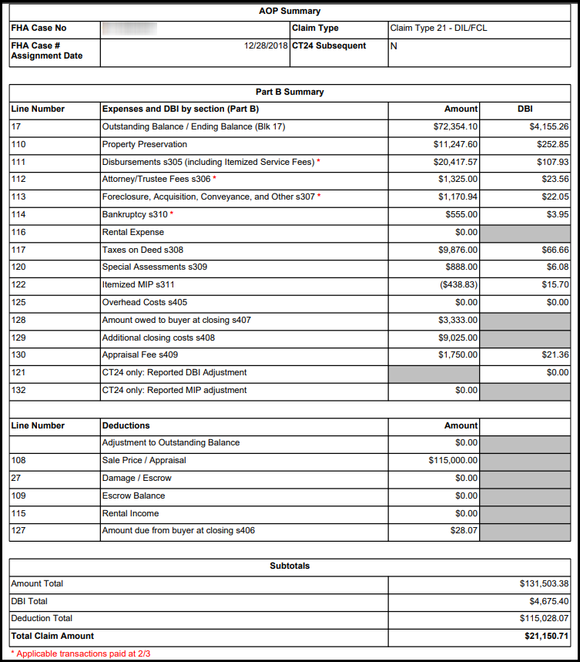
The amounts on Page 2 correspond to the total amounts paid on the claim, by section of the claim form.
The red asterisk appears on transaction categories which can be paid at 2/3, followed by a note at the bottom of the page stating “* Applicable transactions paid at 2/3”. This note does not indicate that any transactions in that category were paid at 2/3 on the claim but highlights which categories can be paid at 2/3. Existing rules for which transactions are paid at 2/3 have not changed and continue to be based on the loan’s FHA Case # Assigned Date, Transaction Category and/ or specific Transaction Type.

New report, “Claim AOP Amounts” was added to Servicer section of the Reports Module. To appear on the report a claim must be Submitted for Payment. For loans with Submitted for Payment step completion date before the implementation of this release, data on the report is present but should be used with caution since some previous claims were paid using different logic in place at the time of the claim payment.
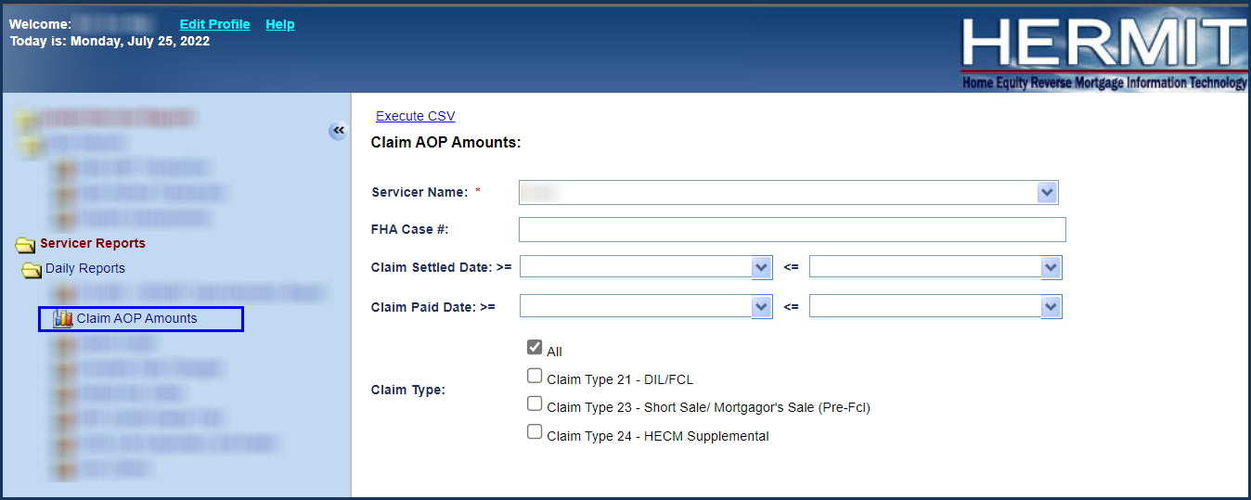

Claim AOP Amount Report field list:
Field name | Description
loan_skey | Loan Skey
fha_case_no | FHA Case #
fha_case_no_assigned_date | FHA Case # Assigned Date
servicer_name | Servicer
max_claim_amt | Max Claim Amt
claim_type | Claim Type
settlement_date | Settlement Date
subsequent_ct24 | CT24 Subsequent
investor_name | Investor
case_status | Case Status
case_sub_status | Case Sub Status
dbi_from_date | Debenture Interest Start Date
dbi_to_date | Debenture Interest End Date
claim_curtailed | Curtailed
dbi_int_rate | Debenture Interest Rate
parta_hud_comments | Part A HUD Comments
aop_total_expense_amt | AOP Total Expense Amt
upb_adj_amt | Deduction. AOP Adjustment to Outstanding Balance. If multiple claims on the loan have Adjustment to Outstanding Balance amount, this is the sum across all claims.
ct24_upb_adj_amt | Deduction. AOP Adjustment to Outstanding Balance for the current CT24 only. Does not include sum across all claims.
upb_amt | Block 17 UPB
upb_debenture_int_amt | Debenture Interest on UPB
b110_colb_additions | Expenses Line 110 (Protection and Preservation)
b110_colc_interest | Interest Line 110 (Protection and Preservation)
b111_colb_additions | Expenses Line 111 (s305)
b111_colc_interest | Interest Line 111 (s305)
b112_colb_additions | Expenses Line 112 (s306)
b112_colc_interest | Interest Line 112 (s306)
b113_colb_additions | Expenses Line 113 (s307)
b113_colc_interest | Interest Line 113 (s307)
b114_colb_additions | Expenses Line 114 (s310)
b114_colc_interest | Interest Line 114 (s310)
b116_colb_additions | Expenses Line 116 (Rental Exp)
b117_colb_additions | Expenses Line 117 (s308)
b117_colc_interest | Interest Line 117 (s308)
b120_colb_additions | Expenses Line 120 (s309)
b120_colc_interest | Interest Line 120 (s309)
b122_colb_additions | Expenses Line 122 (s311 MIP)
b122_colc_interest | Interest Line 122 (s311 MIP)
b125_colb_additions | Expenses Line 125 (s405)
b125_colc_interest | Interest Line 125 (s405)
b128_colb_additions | Expenses Line 128 (s407)
b129_colb_additions | Expenses Line 129 (s408)
b130_colb_additions | Expenses Line 130 (s409)
b130_colc_interest | Interest Line 130 (s409)
b121_colc_interest | Interest Line 121c - CT24
b132_colb_additions | Expenses Line 132 - CT24
b109_cola_deductions | Deduction Line 109 Escrow
b115_cola_deductions | Deduction Line 115 Rental Income
b127_cola_deductions | Deduction Line 127 Cost of Living
b108_cola_deductions | Deduction Line 108 Sale Price
b27_estimate_damage | Deduction Line 27 Estimate Damage
net_claim_amt | Total Claim Paid

Prevent an Investor Change After the 27011 is Submitted for CT21, CT23, or CT24 (575661)
HERMIT has been updated to prevent servicers from changing the loan’s investor during the time HUD is reviewing a claim AND between HUD’s approval of the Claim and the Claim Payment. Changes to Investor after a Claim is Paid will be allowed only if there is not a Claim Type 24 in the process of being reviewed by HUD at the time the Investor change is being attempted. This Change will affect both the User Interface (UI), B2G (Servicer File Upload), and Servicer Transfer Page.
Following Error Message will display:
“Investor cannot be changed while claim is in the process of HUD review."
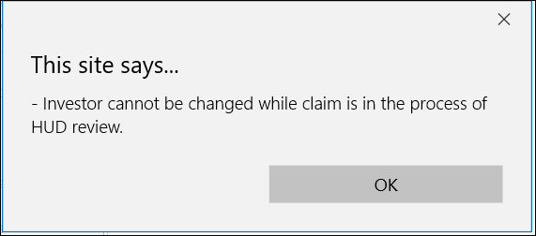
- The User will be Restricted from Changing the Investor when the CT21, CT23, or CT 24 is in HUD’s Review. If the Steps “Ready for Review” and “Re Review” are pending completion by HUD, the Investor change will be restricted. If the Claim has been Approved and the Step “Submitted for Payment” has been completed but the Step “Claim Paid” is not yet completed, the Investor Change will be restricted.
- The User will only be allowed to Change the Investor when the CT21, CT23, or CT24 is in the Servicer view, or the Step “Claim Paid” has been completed and the CT24 is not in HUD’s review.
Restrict Investor Change via B2G (Batch > Servicer File Upload)
If user attempts to change Investor via the B2G file and there is an Active Claim Type 21 and 23 with timeline step “Servicer Files Claim – 27011” that has a complete date AND “Ready for Review” exists and does NOT have a complete date, OR if timeline step “Resubmit Claim 27011” has a complete date AND any “Re Review” step exists and does NOT have a complete date, the system validation shall prevent the transfer from being added and an error message will appear. New validation error message will read “Investor cannot be changed while claim is in the process of HUD review.”
Restrict Investor Change via Batch > Servicer Transfer List
The Servicer Transfer Page will only display the Investor Change that was allowed. The Restricted Investor Change will not be shown on the Servicer Transfer Page.
File Upload Exception Report
The File Upload Exception Report under HERMIT Support > Daily Reports shall display a new message when the conditions stated above on the B2G prevents an investor transfer from being scheduled. The new message will read “Investor cannot be changed while claim is in the process of HUD review.”

HUD Only Related Changes / Assigned Loans

Repurchase (582646)
Upon clicking YES on the Certify message, the Servicer on the loan will immediately be updated from the HUD NSC Contractor to the Servicer that was selected to Repurchase the loan and CT 22 timeline will be inactivated.

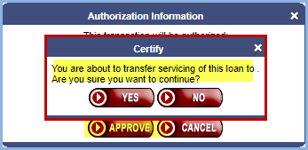

Add a new step and Write-Off worksheet to Write-Off Timeline (539298)
A new step was added to Assigned/Disposition/Write-Off Review timeline along with a new Write-Off worksheet. Write-Off worksheet will calculate and auto image within Write-Off Review timeline.
New step is called Prepare Write-Off Calculation Worksheet. New worksheet called Write-Off Calculation Worksheet will be auto imaged in the Document area when Prepare Write-Off Calculation Worksheet step is completed.

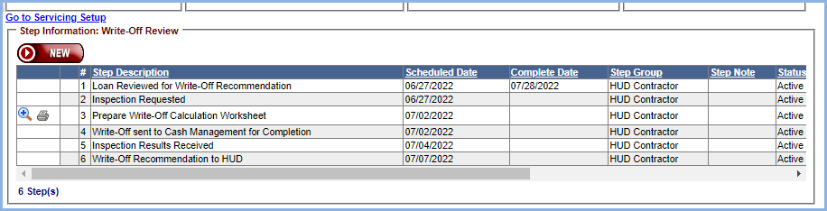
When user clicks on printer or view icon, following Modify Letter Fields page will appear where user can select/update as necessary.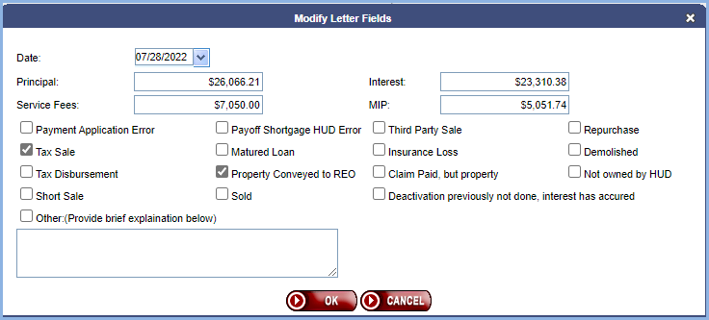
Upon clicking on OK, Write-Off sheet will be generated with selected items from the Modify Letter Fields. 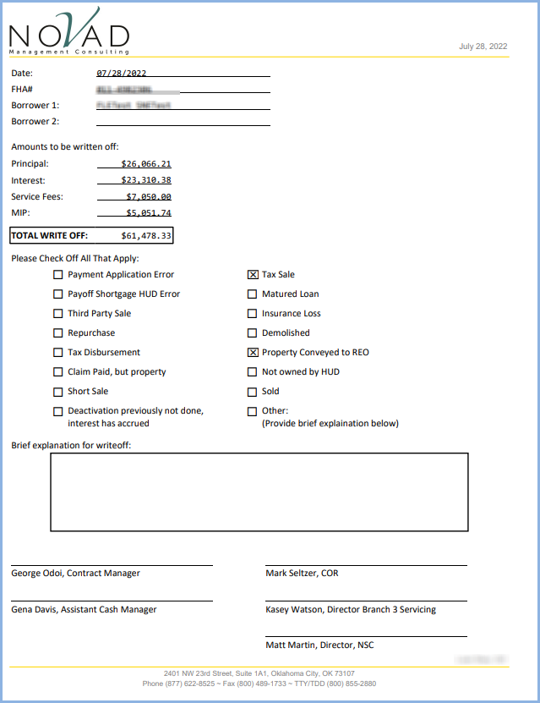

Write-Off Worksheet will be auto imaged to Document area.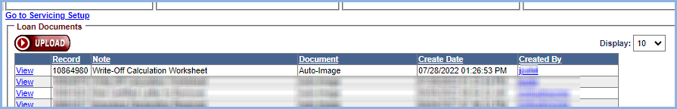

Add Loan Bal on Trans Dt Column to the Loan Transactions Page (539459)
A new column labeled Loan Bal on Trans Dt will be added to the Loan Transaction Result area on Transaction screen. It will be updated after each transaction posted and will display the total loan balance as of the transaction date after each posted transaction. The Loan Bal on Trans Dt column will be viewable in the Export Transactions and Print Transactions options.
